Bothwell Golf Club 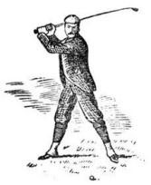 Inaugural Member
________________________________PO Box 68, Bothwell Tasmania 7030 ______________________ Tasmanian Golf Hall Of Fame

The 2021 HIGHLAND CHAMPIONSHIPS
A Toogood Trophy event!
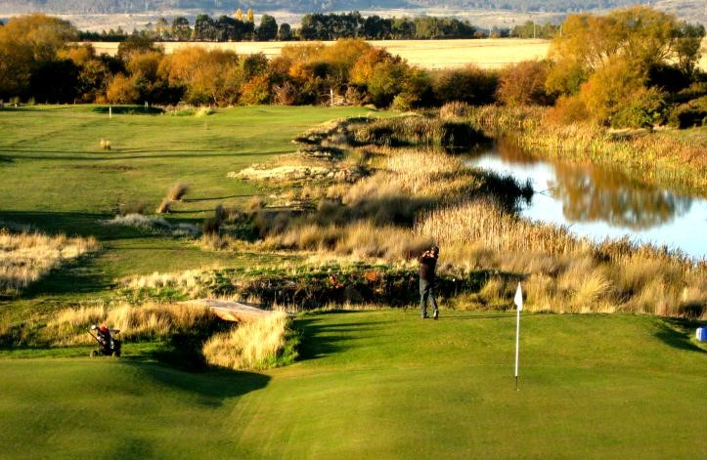

SATURDAY, 17 JULY

Gross & Net prizes for A, B & C Grade
Nearest the Pins on all par 3s
Highland Champion.
Entry fee $35 (payable on the day), with lunch provided.
Tee times available from 9.00 am to 11.30 am.

To enter, please contact Magne on handicap@bothwellgolfclub.com,
or phone Leanne on 6259 5508.
(No later than Tuesday, 13 July)
For more info go to our web site: www.bothwellgolfclub.com

